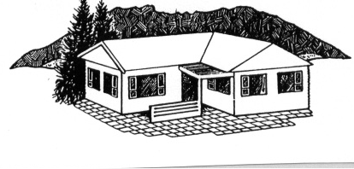
RAGLAN COMMUNITY HOUSE Society Inc.
PO Box 171
Raglan
Phone (07) 825-8142
Fax (07) 825-7112

Email r_ch@xtra.co.nz

APPLICATION FOR THE POSITION OF _______________________________________

The information requested on this application form is used solely for the purpose of assessing the suitability of the person applying for the position.

PLEASE ANSWER ALL QUESTIONS FULLY. THIS FORM WILL BE KEPT CONFIDENTIAL IN ACCORDANCE TO THE PRIVACY ACT 1993

SURNAME _______First Names

ADDRESS ______

PHONE Home :___________________ Work: ___________________ Mobile: __________________
Email: ________________________________________________DATE OF BIRTH _______________
DRIVERS LICENCE Number : _______________________ Class: __________________
EDUCATION YEARS: ______ QUALIFICATIONS: ________________________

Secondary

Tertiary

PROFESSIONAL QUALIFICATIONS, SKILLS, ASSOCIATIONS ETC.

MEMBERSHIP OF RELEVANT PROFESSIONAL ASSOCIATIONS

EMPLOYMENT HISTORY

PRESENT OR MOST RECENT EMPLOYER:

Address

Position held From_________ to________

Key Duties and Responsibilities ________________________

________________________

________________________

Reason for Leaving: __________________________________________________________________

PREVIOUS EMPLOYER

Address From To

Position Held

Key Duties and Responsibilities

Reason for Leaving

DO YOU HAVE A CRIMINAL RECORD? No Yes Details

PERSONAL REFEREES Please supply two referees who are not relatives and who do not reside at the same address as you. Note: Referees will only be contacted after any initial interview.

NAME NAME

ADDRESS ADDRESS

PHONE NUMBER PHONE NUMBER

Do you require a permit to work in New Zealand No Yes
If yes be prepared to produce it.

HEALTH DECLARATION

Do you have a medical condition including those caused by gradual process, disease or infection which might affect your ability to preform the job for which you are applying for? No Yes

If yes please specify

DECLARATION.

I declare that the information supplied by me in support of my application is true and correct. I acknowledge
that if I give information that is incorrect, misleading or omit information in my application that is of significance to my application, I may be disqualified or, if appointed, liable for summary dismissal. I understand that if I give any false information in relation to my medical history may result in a loss of compensation or prejudice my entitlement to paid sick leave.

SIGNED: _________________________________ DATE: ________________________

Please return the completed application form with your CV and a covering letter in a sealed envelope to:

Vacancy: House Manager
Raglan Community House
P.O.Box 171
RAGLAN 3225

